| **2022-2023 Home and School Meeting Schedule**  Click the date (then “Bookmark”) to go directly to that meeting’s agenda  All meetings are held at **7pm** | | | | |
| --- | --- | --- | --- | --- |
| 9/7/2022 | 10/5/2022 | 11/2/2022 | 12/7/2022 | 1/4/2023? |
| 2/1/2023 | 3/1/2023 | 4/5/2023 | 5/3/2023 | 6/7/2023? |

Want to add to the agenda ahead of time? Email [westbrookparkhands@gmail.com](mailto:westbrookparkhands@gmail.com) or directly to Mr. Comfort

**WBP Home and School Association 2022-2023 Board**

Genesa Kenney - President

Tracy Chidester - Vice President

Dawn Zaffiri - Treasurer

Sydney Tassone - Secretary

Alyson Weston - Fundraising Chair

Elizabeth Calcagni - co-secretary

Ro Kent - co-fundraising

| Meeting Details | **Date: 9/7/2022 at 7:00pm**  Google Link: <https://meet.google.com/owa-xmod-wqp?hs=122&authuser=0> |
| --- | --- |
| Welcome |  |
| Principal’s Report   * Announcements * Title 1 Report | * Introduce staff in attendance * Celebrate positive start to school year * Staff Gratitude for appreciation luncheon provided by Home and School in August * Car line - be safe, do not walk up (see below directions and image) * Reminder of safety and student usage of cell phone in/out of school * Reminder of COVID safety and staying home when child feels ill - mask-wearing reminders when applicable * Title 1   + Schoolwide title 1 (only one on DHMS side of district, all on BHMS are)   + Money to get parents involved in school (ie: meet and greet ice cream)   + Student support and resources (ie: MTSS intervention materials) |
| WBP in-school/district-sponsored Upcoming Events | * September 9th Spirit Day   + Spirit wear is not yet ready, more to come on this * Sept. 14th - WBP Back to School Night 6:30pm at WBP (and online for virtual learners?) * Early Dismissal First Wednesday of Every Month (same as the meeting schedule above) |
| Home and School Board Update | * Introduction of Home and School Board Members * H & S Folders * H & S Facebook Page   + Join Link: <https://www.facebook.com/groups/westbrookparkhands/> * H & S Venmo/Money   + @westbrookparkes * Volunteers for H & S Events |
| WBP Home and School Upcoming Events/Fundraising Opportunities | * Purpose of Fundraising: * Upcoming Events:   + September 9 - Duct Tape The Principal   + Sept. 16th - Putt Putt   + Sept. 19th - Catalog Fundraiser   + Beginning now, continuing through to June 2023 - RaiseRight App Gift Card Fundraiser     - Sign up by downloading the smartphone app RaiseRight     - Enrollment Code: AJZ1P3E5IQTC     - Reach out to Sydney Tassone with questions or for support through westbrookparkhands@gmail.com |
| 5th Grade Committee Update | * Introduce lead, purpose and goal of 5th Grade Committee * Band App * Sept. 25th - 5th Grade Car Wash |
| Open Forum | * Celebrations/Questions/Concerns/Suggestions/Etc from all attendees * Let’s discuss spiritwear/WBP Shirts - home and school is working with a new vendor and are hoping to have it set up soon. For the first spirit day we encourage your child to wear purple and/or gold if they do not have any spiritwear * Carline and adult/child safety discussed for morning/afternoon pick up * Picture day - end of October * Home and School Mtgs at WBP and DHMS are the same night and time - tough to schedule and make them all work |
| Next Meeting Reminder | Date: 10/5/2022 at 7:00pm  Google Meet Link: forthcoming |
| Helpful WBP/UDSD Links/Reminders | * 9/7/22 Wednesday Folder: <https://www.smore.com/874se-westbrook-park-elementary-school?ref=email-content#w-1954030349> * 8/31/22 Wednesday Folder: <https://www.smore.com/8gb9n-westbrook-park-elementary-school?ref=email-content#w-1954030349> * Back to School Email: <https://www.smore.com/ewrzj-westbrook-park-elementary-school?ref=email-content#w-1954030349> * Attendance email: [wpes-attendance@upperdarbysd.org](mailto:wpes-attendance@upperdarbysd.org) must be sent with the student’s name, Room, Date of Absence, Reason for Absence and Parent name. |

**Drop-off/Pick-up procedures: Details in 8/26/22 Email from Mr. Comfort and on FB page**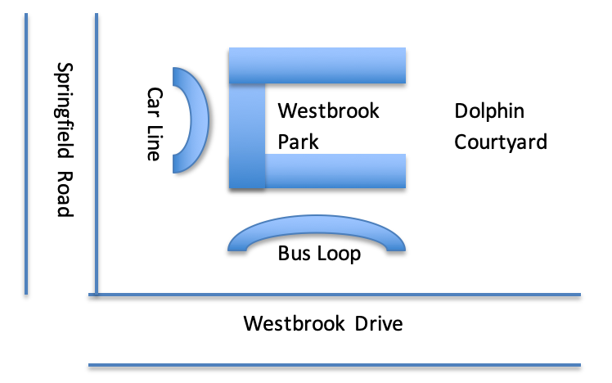

| Meeting Details | **D****ate: 10/5/2022 at 7:00pm**  Google Meet Link: |
| --- | --- |
| Welcome |  |
| Principal’s Report   * Announcements * Title 1 Report |  |
| WBP in-school/district-sponsored Upcoming Events |  |
| Home and School Board Update |  |
| WBP Home and School Upcoming Events |  |
| 5th Grade Committee Update |  |
| Open Forum |  |
| Helpful WBP/UDSD Links/Reminders |  |
| Next Meeting Reminder | Date: 11/2/2022 at 7:00pm |

| Meeting Details | **Date: 11/2/2022 at 7:00pm**  Google Meet Link: |
| --- | --- |
| Welcome |  |
| Principal’s Report   * Announcements * Title 1 Report |  |
| WBP in-school/district-sponsored Upcoming Events |  |
| Home and School Board Update |  |
| WBP Home and School Upcoming Events |  |
| 5th Grade Committee Update |  |
| Open Forum |  |
| Helpful WBP/UDSD Links/Reminders |  |
| Next Meeting Reminder | Date: 12/7/2022 at 7:00pm |

| Meeting Details | **Date: 12/7/2022 at 7:00pm**  Google Meet Link: |
| --- | --- |
| Welcome |  |
| Principal’s Report   * Announcements * Title 1 Report |  |
| WBP in-school/district-sponsored Upcoming Events |  |
| Home and School Board Update |  |
| WBP Home and School Upcoming Events |  |
| 5th Grade Committee Update |  |
| Open Forum |  |
| Helpful WBP/UDSD Links/Reminders |  |
| Next Meeting Reminder | Date: 10/5/2022 at 7:00pm  Zoom Link/Location in WBP: |

| Meeting Details | **Date: 1/4/2023 at 7:00pm**  Google Meet Link: |
| --- | --- |
| Welcome |  |
| Principal’s Report   * Announcements * Title 1 Report |  |
| WBP in-school/district-sponsored Upcoming Events |  |
| Home and School Board Update |  |
| WBP Home and School Upcoming Events |  |
| 5th Grade Committee Update |  |
| Open Forum |  |
| Helpful WBP/UDSD Links/Reminders |  |
| Next Meeting Reminder | Date: 10/5/2022 at 7:00pm  Zoom Link/Location in WBP: |

| Meeting Details | **Date: 2/1/2023 at 7:00pm**  Google Meet Link: |
| --- | --- |
| Welcome |  |
| Principal’s Report   * Announcements * Title 1 Report |  |
| WBP in-school/district-sponsored Upcoming Events |  |
| Home and School Board Update |  |
| WBP Home and School Upcoming Events |  |
| 5th Grade Committee Update |  |
| Open Forum |  |
| Helpful WBP/UDSD Links/Reminders |  |
| Next Meeting Reminder | Date: 10/5/2022 at 7:00pm  Zoom Link/Location in WBP: |

| Meeting Details | **Date: 3/1/2023 at 7:00pm**  Google Meet Link: |
| --- | --- |
| Welcome |  |
| Principal’s Report   * Announcements * Title 1 Report |  |
| WBP in-school/district-sponsored Upcoming Events |  |
| Home and School Board Update |  |
| WBP Home and School Upcoming Events |  |
| 5th Grade Committee Update |  |
| Open Forum |  |
| Helpful WBP/UDSD Links/Reminders |  |
| Next Meeting Reminder | Date: 10/5/2022 at 7:00pm  Zoom Link/Location in WBP: |

| Meeting Details | **Date: 4/5/2023 at 7:00pm**  Google Meet Link: |
| --- | --- |
| Welcome |  |
| Principal’s Report   * Announcements * Title 1 Report |  |
| WBP in-school/district-sponsored Upcoming Events |  |
| Home and School Board Update |  |
| WBP Home and School Upcoming Events |  |
| 5th Grade Committee Update |  |
| Open Forum |  |
| Helpful WBP/UDSD Links/Reminders |  |
| Next Meeting Reminder | Date: 10/5/2022 at 7:00pm  Zoom Link/Location in WBP: |

| Meeting Details | **Date: 5/3/2023 at 7:00pm**  Google Meet Link: |
| --- | --- |
| Welcome |  |
| Principal’s Report   * Announcements * Title 1 Report |  |
| WBP in-school/district-sponsored Upcoming Events |  |
| Home and School Board Update |  |
| WBP Home and School Upcoming Events |  |
| 5th Grade Committee Update |  |
| Open Forum |  |
| Helpful WBP/UDSD Links/Reminders |  |
| Next Meeting Reminder | Date: 10/5/2022 at 7:00pm  Zoom Link/Location in WBP: |

| Meeting Details | **Date: 6/7/2023 at 7:00pm**  Google Meet Link: |
| --- | --- |
| Welcome |  |
| Principal’s Report   * Announcements * Title 1 Report |  |
| WBP in-school/district-sponsored Upcoming Events |  |
| Home and School Board Update |  |
| WBP Home and School Upcoming Events |  |
| 5th Grade Committee Update |  |
| Open Forum |  |
| Helpful WBP/UDSD Links/Reminders |  |
| Next Meeting Reminder | Date: 10/5/2022 at 7:00pm  Zoom Link/Location in WBP: |